
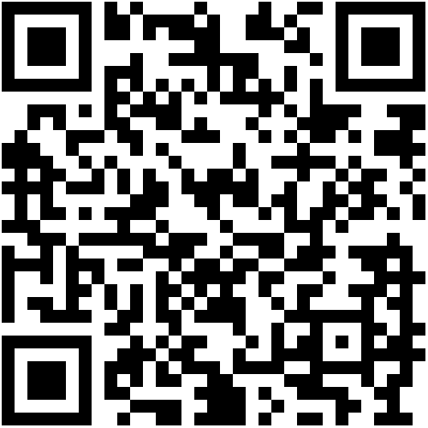

Curriculum vitae
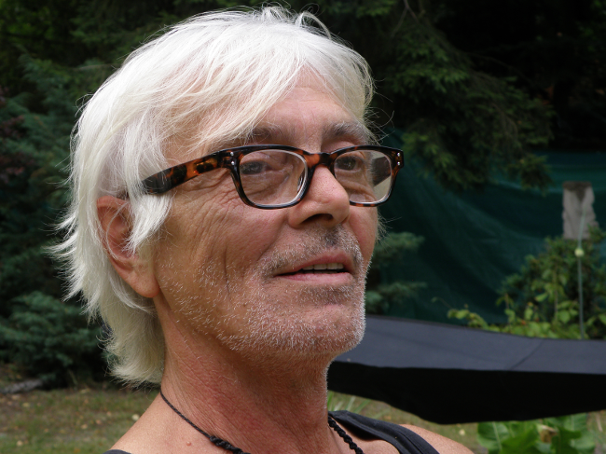
Tjen Heyligen
°02.02.1956
Jozef Hendrickxstraat 60 bus 7
2900 Schoten
Belgium

+32 477 90 19 09
tjen.heyligen@gmail.com
www.tjenheyligen.be

1992-1999:
Sculpting at the Academy of Fine Arts in Mortsel, led by Jef Mouton

Exhibitions in Belgium, The Netherlands, Finland, Turkey, South Korea.

Member of
- Kamer voor Plastische Kunsten, Schoten
- Art 27, Heusden-Zolder

